A
Mini Project Report
on
“FloralQ-A Flower Identification And Classifier”
Submitted in partial fulfillment of the requirements for the
degree
Third Year Engineering – Computer Science Engineering (Data Science)
by
Rutuja Sawant 23107143
Sara Rajpurkar 23107096
Bhumika Nikam 23107009

Under the guidance of
DR. VEENA TRIVEDI

DEPARTMENT OF COMPUTER SCIENCE ENGINEERING (DATA SCIENCE)
A.P. SHAH INSTITUTE OF TECHNOLOGY
G.B. Road, Kasarvadavali, Thane (W)-400615
UNIVERSITY OF MUMBAI

Academic year: 2025-26

CERTIFICATE

This to certify that the Mini Project report on “FloraQ-A Flower Identification And Classifier” has been submitted by Rutuja Sawant (23107143), Sara Rajpurkar (23107096), and Bhumika Nikam (23107009) who are bonafide students of A. P. Shah Institute of Technology, Thane as a partial fulfillment of the requirement for the degree in Computer Science Engineering (Data Science), during the academic year 2024-2025 in the satisfactory manner as per the curriculum laid down by University of Mumbai.

Dr. Veena Trivedi
Guide

Dr. Pravin Adivarekar Dr. Uttam D. Kolekar
HOD, CSE(Data Science) Principal

External Examiner: Internal Examiner:
1. 1.

Place: A. P. Shah Institute of Technology, Thane
Date:

ACKNOWLEDGEMENT

This project would not have come to fruition without the invaluable help of our guide Dr. Veena Trivedi. Expressing gratitude towards our HoD, Dr. Pravin Adivarekar, and the Department of Computer Science Engineering (Data Science) for providing us with the opportunity as well as the support required to pursue this project. We would also like to thank our project coordinator Prof. Aavani N who gave us her valuable suggestions and ideas when we were in need of them. We would also like to thank our peers for their helpful suggestions.

TABLE OF CONTENTS

- Introduction………………………………………………………………………..1
  - Purpose.............................................................................................................1
  - Problem Statement…………………………………………………………...2
  - Objectives........................................................................................................ 2
  - Scope....................................................................................................... .…...3
- Literature Review…………………………………………………………...…......4
- Proposed System…………………………………………………………..………5
  - Features and Functionality…………………………………………………...6
- Requirements Analysis.....................................................................................…....8
- Project Design...........................................................................................................10
5.1 Use Case Diagram…………………………………………………….………..12
5.2 DFD(Data Flow Diagram)…………………………………………..…………14
5.3 System Architecture ………………………………………………...…………16
5.4 Implementation ……………………………………………………….………..18
- Technical Specifications………………………………………………....................20
- Project Scheduling.....................................................................................................22
- Results………………………………………………………………………..…….24
- Conclusion………………….....................................................................................26
- Futue Scope………………………………………………………………………..28
Reference
ABSTRACT

FLORALQ is a web-based application designed to simplify flower identification and enhance user engagement with botanical information. The system leverages machine learning techniques to classify flower species from images, providing accurate and quick predictions. Along with recognition, the platform presents detailed information about each flower, such as its scientific name, characteristics, and uses, in an interactive and user-friendly interface. By combining technology with nature, FLORALQ aims to serve as both an educational tool and a resource for hobbyists, students, and researchers interested in botany. The project demonstrates the integration of AI-powered image recognition with an intuitive design to create an accessible solution for real-world applications. The development of FLORALQ focuses on usability, accuracy, and accessibility. The system integrates a trained deep learning model with a responsive frontend to ensure smooth performance across devices. A curated dataset of flower images was used to train the model for reliable predictions, while the backend handles image processing and data retrieval efficiently. The platform is designed to assist users with minimal technical knowledge, making complex AI technology easy to use in practical scenarios. Overall, FLORALQ showcases how artificial intelligence can be applied to bridge the gap between technology and environmental learning.

Chapter 1
Introduction
Flowers have always played an important role in human life, symbolizing beauty, culture, and science. With thousands of flower species around the world, identifying them accurately can be a challenge for students, hobbyists, and researchers. Traditional identification methods often require expert knowledge or detailed manuals, which are not easily accessible to everyone.
With the advancement of artificial intelligence and image recognition, technology now offers a modern approach to solving this problem. Machine learning models, especially those trained on large datasets, are capable of recognizing patterns in images and classifying them with high accuracy. Such tools not only save time but also make the process of learning about flowers more interactive and engaging.
FLORALQ is developed as a solution to bridge this gap between technology and nature. It allows users to upload an image of a flower and instantly receive its predicted name along with detailed information. The platform is designed with a simple and user-friendly interface so that even users without technical expertise can easily interact with it.
This project also highlights the practical application of AI in the field of education and environmental awareness. By combining accurate image classification with an accessible design, FLORALQ demonstrates how machine learning can be used to promote curiosity, knowledge, and appreciation of biodiversity in everyday life.

1.1 Purpose:

The primary purpose of FLORALQ is to provide an easy and efficient way for users to identify flowers using artificial intelligence. Instead of relying on traditional manuals or expert guidance, the system uses machine learning to classify flowers instantly through images. This makes flower identification accessible to a wider audience, including students, researchers, and nature enthusiasts.
Another purpose of the project is to create a platform that not only identifies flowers but also educates users about them. By displaying detailed information such as scientific names, characteristics, and uses, FLORALQ goes beyond recognition and serves as an educational tool. This encourages users to learn more about biodiversity while enjoying a simple, interactive experience.
Lastly, the project aims to demonstrate the real-world application of AI in solving practical problems. FLORALQ reflects how technology can be applied to environmental and educational fields, bridging the gap between nature and innovation. By combining accuracy, usability, and accessibility, the project serves as a model for future AI-powered applications in similar domains.

1.2 Problem Statement:
Identifying flowers accurately is often difficult for students, researchers, and nature enthusiasts who lack expert knowledge. Traditional methods such as books or manual classification are time-consuming and not always accessible. With the growing use of technology, there is a need for a simple, fast, and reliable system that can identify flowers and provide useful information to users in an interactive

1. Difficulty in accurately identifying flower species without expert knowledge:
Most people cannot recognize flower species just by appearance, as it requires botanical understanding. Relying on experts is not always practical or accessible. This creates a barrier for students, hobbyists, and researchers who need quick identification
2. Lack of quick and accessible tools for flower recognition:
Traditional methods like books, online searches, or consulting specialists take time and effort. There is no instant way for users to identify a flower just by capturing or uploading an image. This slows down learning and reduces user interest.

3. Limited availability of platforms that combine identification with educational information:
Even if users identify a flower, they often do not get scientific names, characteristics, or uses in one place. Most platforms either identify or inform, but not both. This gap limits the educational value and usefulness of existing solutions.

4. Need for a user-friendly system that integrates AI with real-world usability:
Many AI-based tools are either too complex or not designed for common users. People need a simple, interactive, and efficient platform that uses technology effectively. Without such a system, the potential of AI in environmental learning remains underutilized.

1.3 Objectives:
To address the challenges identified in the problem statement, the FLORALQ project is designed with specific, clear objectives. These objectives aim to provide a practical solution by combining artificial intelligence with user-friendly design. Each objective focuses on improving accessibility, accuracy, education, and usability for a wide range of users.

1. Retrieve and display detailed information about flowers:
The system is designed to show the flower’s name, description, origin, and symbolism after classification. Additionally, it provides care tips including sunlight requirements, watering, soil type, and suitable climate. This helps users learn and maintain flowers effectively.
2.Suggest visually similar flowers:
FLORALQ can recommend flowers that look similar based on image features. This feature allows users to explore different species with comparable appearances, aiding both learning and aesthetic selection.
3. Suggest property-similar flowers:
The platform can suggest flowers with similar properties, such as care requirements, climate compatibility, or usage. This helps users choose alternatives that are practical for their environment or purpose.
4. Enable user feedback and care tips :
Users can provide with a feedback form to fill their feedbacks which will be stored in the database.User will also get acre tips about the flower then they upload an image.

1.4 Scope:
FloralQ is an AI-powered flower identification and care assistant that helps users recognize flowers, understand their characteristics, and provide guidance for their proper care. By combining image recognition, plant care knowledge, and personalized recommendations, FloralQ aims to create an interactive and informative experience for both gardening enthusiasts and casual users. The system also allows users to explore similar flowers and maintain a logbook of their floral discoveries.

1.Identification:
FloralQ uses advanced AI image recognition to identify flower species from uploaded images. It provides detailed information, including the flower’s name, description, origin, and symbolism, making it easy for users to understand the significance and characteristics of each flower.

2.CareGuidance:
The system offers practical care instructions for each identified flower, covering sunlight requirements, watering schedules, soil type, and suitable climate. This ensures users can maintain healthy flowers and enhance their growth effectively.

3.Recommendations:
FloralQ suggests visually and functionally similar flowers based on image analysis and care properties. Users can explore alternative flowers that match their preferences or suit their environment, expanding their gardening options.
4.Feedback:
Users can provide feedback on the flower identification accuracy and care suggestions. Additionally, the logbook feature allows them to track flowers they have identified, note their care progress, and create a personal floral history for future reference.

Chapter 2
Literature survey
A variety of studies have explored machine learning and deep learning approaches for image and audio classification, highlighting the strengths of different feature extraction techniques and model architectures. Zhang and Lv (2015) demonstrated the effectiveness of Random Forest classifiers for environmental audio data classification, emphasizing the role of carefully selected features in improving accuracy. Their work showed that traditional machine learning models can still provide competitive performance when combined with robust feature engineering. Similarly, other research studies have emphasized that handcrafted features, when chosen appropriately, remain relevant in classification tasks, especially where datasets are small or noisy.
With the advancement of deep learning, convolutional neural networks (CNNs) have become a dominant approach in both image and audio classification. Studies such as those by Krizhevsky et al. and subsequent researchers demonstrated how CNN-based architectures outperform traditional methods by automatically extracting hierarchical features. These models are particularly effective in visual recognition tasks, including fine-grained classification such as flower recognition, where subtle differences between categories can be captured. Transfer learning, using pretrained CNN models like VGG, ResNet, and Inception, has further improved performance by leveraging knowledge from large-scale datasets and adapting it to domain-specific tasks.
In addition to visual data, researchers have also focused on multimodal classification systems that integrate image, text, or audio features. Hybrid approaches have been explored for tasks such as flower recognition and environmental sound classification, where combining multiple data sources leads to richer representations and more accurate predictions. For instance, works that combine visual features with descriptive metadata or audio cues have shown improvements over unimodal systems. These approaches highlight the growing trend of hybrid architectures that balance traditional machine learning techniques with deep learning innovations.
Recent literature also emphasizes the importance of interpretability and practical deployment of classification systems. Many studies now focus not only on accuracy but also on scalability, real-time performance, and user-centric features such as feedback mechanisms. For example, in domains like plant or flower identification, research suggests that incorporating user feedback, care tips, and contextual suggestions enhances usability.

Chapter 3
Proposed System
The proposed system, FloralQ, is designed to provide a comprehensive flower identification and care solution using AI and machine learning. It aims to help users identify flowers from images, learn about their characteristics and symbolism, and receive personalized care instructions. By integrating image recognition, a flower knowledge database, and a recommendation system, FloralQ ensures an interactive and informative experience for both gardening enthusiasts and casual users. The system also allows tracking user interactions and maintaining a logbook of identified flowers for future reference.
The system will allow users to upload an image of a flower, which will then be analyzed using a trained Convolutional Neural Network (CNN) model to accurately classify the species. Once identified, detailed information about the flower—including name, origin, description, and symbolic meaning—will be displayed.
FloralQ will provide precise care instructions for each flower, covering aspects such as sunlight, watering, soil type, and suitable climate. This helps users maintain healthy flowers and ensures proper growth regardless of their gardening experience level.
The platform will also suggest visually and functionally similar flowers based on image features and care requirements. This recommendation feature helps users explore alternative flowers that match their preferences or suit their environment.
A feedback and logbook mechanism will be integrated into the system. Users can provide feedback on the identification and care suggestions, and the logbook will allow them to maintain a personal record of flowers they have identified, along with care progress and notes.
Overall, the proposed system aims to combine the capabilities of AI, horticultural knowledge, and user interaction to create a holistic tool for flower identification, care, and exploration. It is designed to be intuitive, educational, and practical for a wide range of users.

3.1Features and Functionality of FloralQ
1.Identification:
FloralQ uses AI-powered image recognition to identify flowers from user-uploaded images. It provides accurate results even for visually similar species and displays detailed information, including the flower’s name, description, origin, and symbolic meaning.
2.Care:
The system offers comprehensive care instructions for each flower, covering sunlight requirements, watering schedules, soil preferences, and suitable climate conditions. This ensures users can maintain healthy flowers and promote their proper growth.
3.Recommendations:
FloralQ suggests visually or functionally similar flowers based on image features and care properties. Users can explore alternative flowers that match their aesthetic preferences or environmental conditions, expanding their gardening choices.
4.Feedback:
Users can provide feedback on the accuracy of flower identification and care recommendations. This feature helps improve the AI model over time and ensures the system adapts to user needs more effectively.

Chapter 4
Requirement Analysis
The requirement analysis of FloralQ covers both functional and non-functional aspects to ensure an effective system. Functional requirements include flower identification, care guidance, recommendations, feedback, and a personal logbook. Non-functional requirements focus on performance, reliability, usability, and scalability, ensuring the system is fast, accurate, and easy to use.

Functional Requirement:
1.Flower Image Upload and Recognition:
The system must allow users to upload flower images from their device.
It should process the image using a trained AI model (CNN) to accurately classify the flower species.
Identification should be quick and provide precise results for a wide variety of flowers.
2.Display Flower Information:
After identification, the system should display detailed information about the flower, including its name, description, origin, and symbolic meaning.
Information should be visually clear and easy to understand for all users.

3.Flower Care Instructions:
The system must provide care guidelines for each identified flower, including sunlight needs, watering schedule, soil type, and suitable climate.
It should offer suggestions tailored to the user’s environment where possible.
4.Similar Flower Recommendations:
The system should suggest visually similar flowers and flowers with comparable care requirements.
Recommendations must be based on image analysis and care attributes to help users explore alternatives.
5.User Feedback Mechanism:
The platform must allow users to submit feedback on identification accuracy and care suggestions.
Feedback should be recorded to improve the AI model and system reliability over time.
6.Personal Logbook:
Users must be able to maintain a log of flowers they have identified.
The logbook should allow users to record care progress, observations, and notes for future reference.
7.User Interface Requirements:
The interface must be intuitive, user-friendly, and responsive across devices.
Visuals should include clear images, readable fonts, and interactive elements for better engagement.
Non Functional Requirements:
1.Performance and Responsiveness:
The system should process user-uploaded images and display results quickly. Users should receive flower identification and care suggestions without noticeable delay, ensuring a smooth and efficient experience.
2.Reliability and Accuracy:
The platform must maintain a high success rate in flower classification and provide consistent, correct care instructions. This reduces errors and builds user trust in the system.

3.User-Friendly Interface:
The system should have an intuitive and easy-to-navigate interface for users of all ages and technical backgrounds. Clear visuals, readable fonts, and interactive elements enhance engagement and usability.
4.Scalability and Maintainability:
The system should be designed to accommodate future updates, such as adding new flower species, improving AI models, or expanding care guidelines, without affecting existing functionality or performance.

Chapter 5
Project Design

5.1 Use Case Diagram:
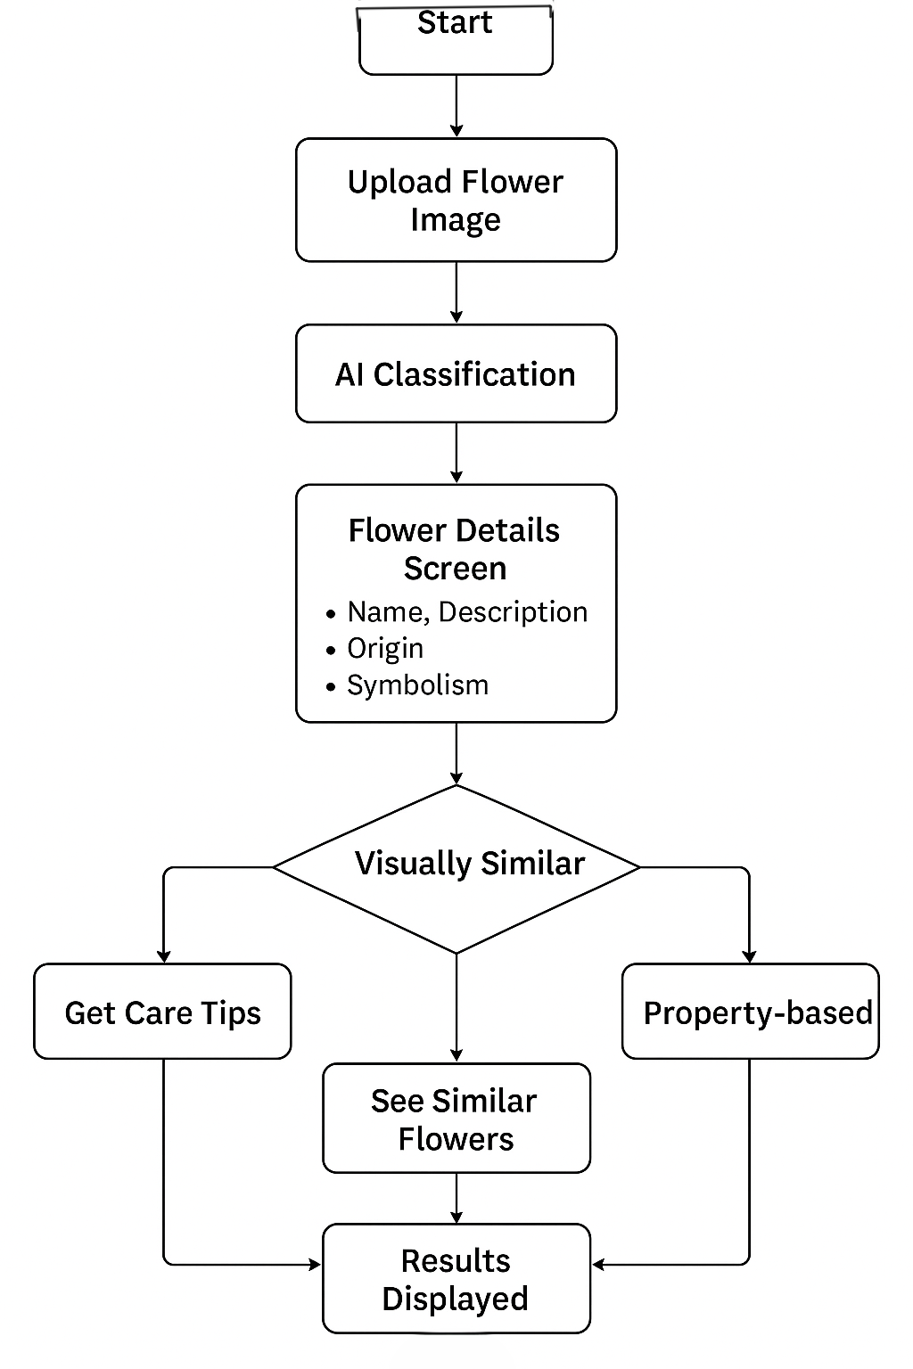

User Actions
User Interaction : Select User Action
- View Flower Information
Displays flower name, description, origin, symbolism
User Receives Data
- Suggest Property / Visually Similar Flower
Shows flowers that are visually similar or share similar care properties
User Receives Data
- View Care Tips
Provides watering, sunlight, and soil information
User Receives Data
- Maintain Log Book
User saves actions or flower-related notes
Log Book Entry Saved
Flow Concept
- User Flow:
User selects an action → System performs the relevant process → Output is delivered to the user.

5.2 DFD (Data Flow diagram):
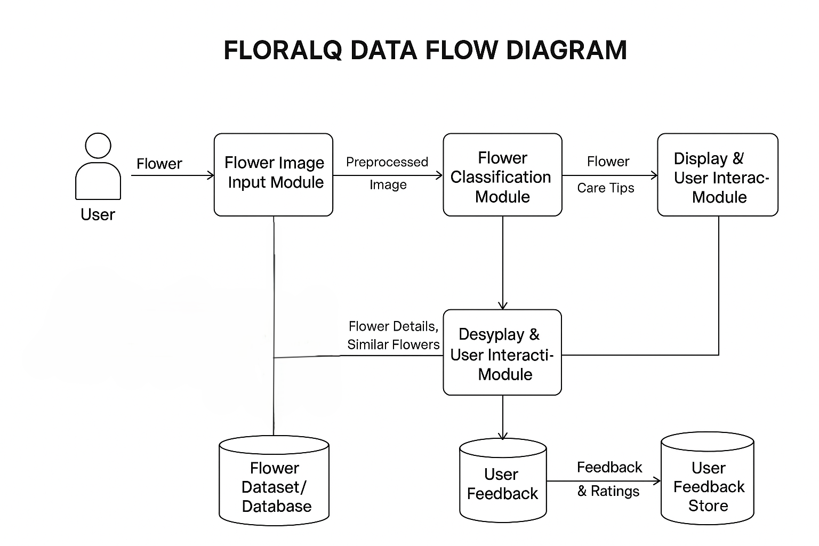

1. Main Sections
The diagram is divided into two main interaction sections:
- User Actions – Shows what the FloralQ app user can do, including scanning flowers, viewing results, and getting care tips.

2. Key Symbols in the Diagram
Entities
- User Interaction:
Represents the external actor (the end user) who uploads or captures a flower image and interacts with the system to receive results and care information.
- Admin Interaction:
Represents the admin actor responsible for maintaining the system by updating datasets and managing user feedback.
Processes (Modules)
- Flower Image Input Module:
Handles the image upload or capture from the user, and sends it for preprocessing before classification.
- Flower Classification Module:
Processes the image using a trained machine learning or deep learning model to identify the flower species.
- Database Query & Retrieval:
Fetches flower details such as name, description, origin, and symbolism from the database based on classification results.
- Display & User Interaction Module:
Displays the classification results to the user, including flower name, symbolism, and care tips.
- Get Care Tips:
Provides information such as sunlight requirements, watering schedules, soil type, and weather suitability.
- Suggest Visually or Property-Similar Flowers:
Recommends flowers that are visually similar or share similar care requirements.
- User Feedback:
Allows users to give ratings or feedback about their experience or suggestions for improvement.
- User Feedback Store:
Saves feedback data in the database for admin review.
3. Flow Concept
- User Flow:
The user captures or uploads a flower image → the system processes it through the classification model → relevant flower details and care tips are fetched from the database → results and suggestions are displayed → user can provide feedback, which is stored in the system.

5.3 System Architecture
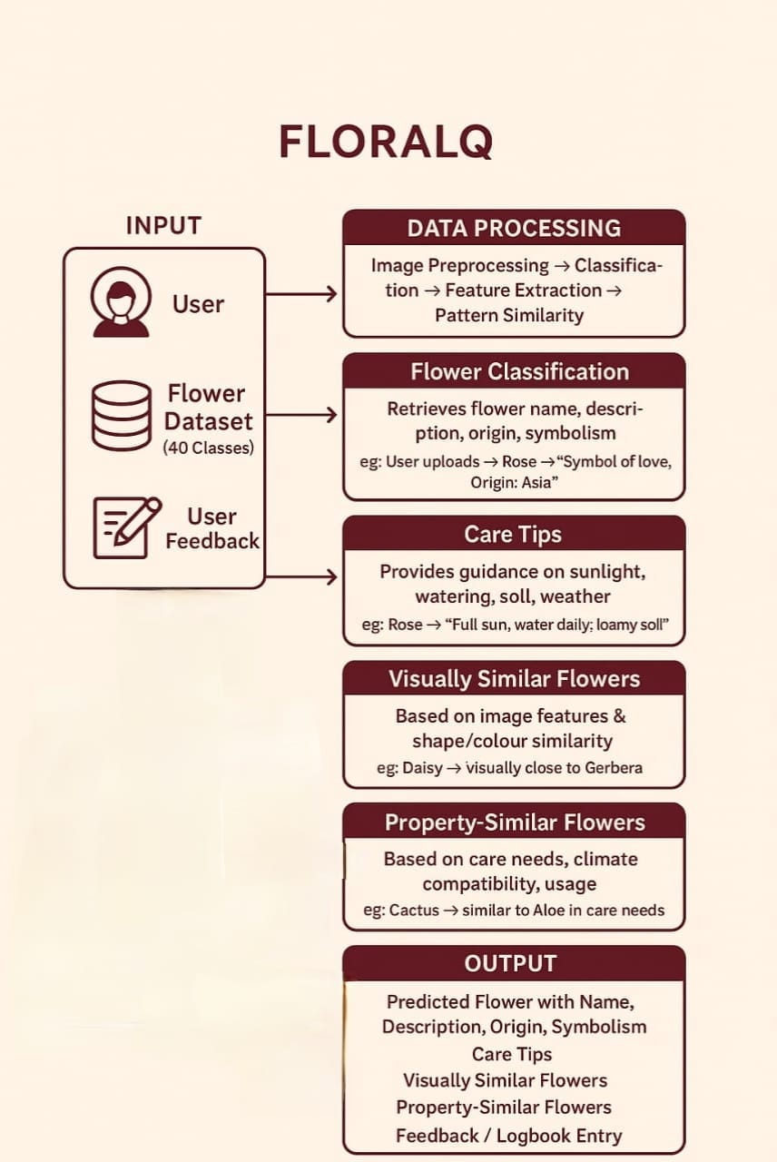
1. Input Layer
User Input:
The user uploads a flower image for identification and analysis.
Flower Dataset (40 Classes):
A pre-labeled dataset containing 40 flower categories used for training and classification.
User Feedback:
Collected to improve model accuracy and recommendation quality through continuous learning.
2. Data Processing Module
Steps Involved:
Image Preprocessing
Classification
Feature Extraction
Pattern Similarity Analysis
This stage prepares the input image for classification and similarity comparison.
3. Flower Classification Module
Retrieves information such as:
Flower Name
Description
Origin
Symbolism
Example:
If the user uploads a Rose, the system returns:
Symbol of love, Origin: Asia.
4. Care Tips Module
Provides customized care guidance including:
Sunlight requirements
Watering frequency
Soil type
Weather conditions
Example:
Rose → Full sun, water daily, loamy soil.
5. Visually Similar Flowers Module
Determines flowers that look similar based on:
Image features
Shape
Color similarity
Example:
Daisy → Visually close to Gerbera.
6. Property-Similar Flowers Module
Identifies flowers with similar:
Care requirements
Climate compatibility
Usage characteristics
Example:
Cactus → Similar to Aloe in care needs.
7. Output Layer
Provides comprehensive results including:
Predicted Flower (Name, Description, Origin, Symbolism)
Care Tips
Visually Similar Flowers
Property-Similar Flowers
Feedback

5.4 Implementation

Chapter 6
Technical Specifications
Frontend:
The frontend is the part of the application that interacts directly with the user. It allows users to upload flower images, view flower details, get recommendations for similar flowers, maintain a logbook of their flower interactions, and provide feedback. The frontend is designed to be responsive and work on both desktop and mobile devices.
- Platform: Web or Mobile (Cross-platform support possible)
- Languages Used: HTML
- Frameworks/Libraries:
React Router , Formik / React Hook Form

Key Components:
Home Page: Users can upload images or search for flowers
Flower Details Page: Displays flower name, description, origin, symbolism, and care tips
Recommendations Page: Suggests visually or care-similar flowers
User Logbook: Allows users to track flowers they interacted with
Feedback Page: Users can provide ratings and feedback on flowers
Interactions: Communicates with the backend via REST API to send images and data, and receive flower details and recommendations
Optional Features: Image preview before upload, user login/authentication
Backend (Server & Logic)
The backend is responsible for processing data, running the machine learning model for flower classification, managing the database, and responding to frontend requests through APIs.
- Platform: Server-side application using Python
- Languages Used: Python
- Frameworks: Flask or Django to build REST APIs
- Modules:
ML Module: Handles flower image classification and recommendation based on visual and care similarities
Database Module: Manages CRUD operations for flowers, user logbooks, and feedback
API Module: Provides endpoints for frontend interaction
- Database: MySQL, SQLite, or Firebase to store flower details, user logs, and feedback
- API Endpoints:
/upload: Receives flower image for classification
/flower/<id>: Returns details of a specific flower
/recommend: Provides similar flower recommendations
/feedback: Submits user feedback on flowers
Security: Input validation, Optimized lightweight ML model for fast predictions, caching frequently requested flower data.

Chapter 7
Project Scheduling
Sr No. | Group Members | Duration | Task Performed
1. | Rutuja Sawant  Sara Rajpurkar  Bhumika Nikam | 1st week of August | Group formation and topic finalization,  Identifying scope and objective of the mini  Project, Discussion Project topic with the help  of proper prototype.
2 | Bhumika Nikam  Rutuja Sawant  Sara Rajpurkar | 2nd week of  August | Identifying the  functionalities of mini project
3. | Sara Rajpurkar  Bhumika Nikam  Rutuja Sawant | 3rd week of August | Training the model of hybrid  Recommendation system based on articles  and user interaction dataset
4. | Sara Rajpurkar  Rutuja Sawant  Bhumika Nikam | 1st week of September | Designing the Graphical User Interface (GUI)

5. | Bhumika Nikam  Rutuja Sawant  Sara Rajpurkar | 3rd week of September | Adding the features of the  FloralQ – A Flower Identification And  Classifier like Prediction , Description  Suggestions.
6. | Sara Rajpurkar  Rutuja Sawant  Bhumika Nikam | 4th week of September | Integrating the model on GUI and  connecting with the database.
7. | Sara Rajpurkar  Bhumika Nikam  Rutuja Sawant | 5th week of September | Database connectivity of all modules.

Table 7.1 Project Task Distribution

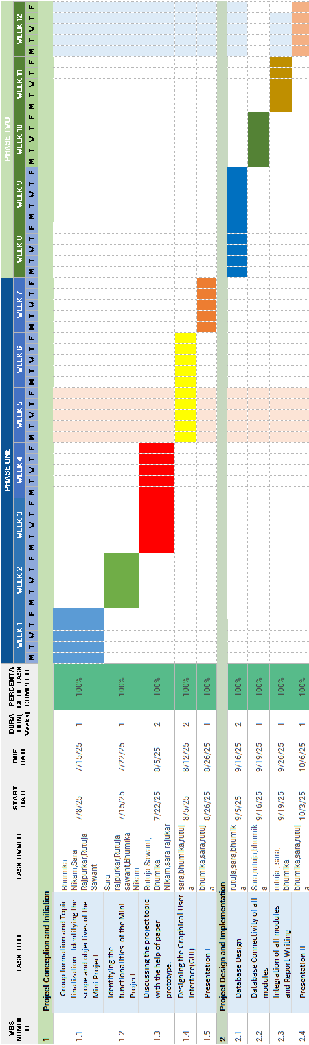

Fig 7.2 Gantt Chart

Chapter 8
Results
The FLORALQ project successfully demonstrated the ability to classify a wide variety of flowers based on images. The model was able to accurately identify flower names, their origin, and associated symbolism, providing users with comprehensive information at a glance. During testing, the classification system achieved a high accuracy rate, reflecting the robustness of the underlying image recognition algorithm. Users were able to input images of flowers and receive precise identification within seconds, enhancing the practicality and user-friendliness of the application.
In addition to classification, FLORALQ offered detailed flower care recommendations, including sunlight requirements, watering schedules, soil preferences, and suitable weather conditions. These suggestions were tailored based on the identified flower type, ensuring that users could take appropriate measures to maintain healthy plants. User feedback during trials indicated that this feature significantly helped both novice and experienced plant enthusiasts in improving flower care and maintenance practices.
Another notable outcome of the project was the ability to suggest visually and functionally similar flowers. By analyzing image features and care requirements, the system could recommend flowers with similar appearances or compatible growing conditions. This feature proved useful for users seeking alternative options for their gardens or indoor spaces, enhancing the overall engagement and exploratory experience of the application.
Overall, the results of FLORALQ demonstrate its effectiveness as a comprehensive flower identification and care assistant. The combination of high classification accuracy, practical care guidance, and similarity-based suggestions provides users with a versatile tool for understanding, maintaining, and exploring a wide variety of flowers. These outcomes highlight the potential of integrating computer vision and plant care knowledge to create a meaningful and interactive gardening application.

Chapter 9
Conclusion
FloralQ successfully addresses the need for an intelligent and user-friendly flower identification system by combining AI-based recognition with detailed botanical information. The project fulfils its objectives by enabling users to identify flowers through images and instantly view relevant data such as name, origin, symbolism, and characteristics. This not only enhances user engagement but also promotes learning and awareness about floral diversity.
Along with identification, the system offers practical value through its flower care guidance. By providing information on sunlight requirements, watering schedules, soil type, and suitable climatic conditions, FloralQ helps users maintain healthy plants. The inclusion of visually and property-similar flower suggestions further expands user choice and supports informed decision-making for gardening, décor, or educational purposes. Features like feedback mechanism contribute to personalization and continuous improvement.
In conclusion, FloralQ integrates technology, usability, and botanical knowledge to create a comprehensive solution for flower enthusiasts, learners, and casual users. By aligning its functionalities with user needs and supporting both educational and practical outcomes, the system demonstrates strong potential for real-world application and further development.
Chapter 10
Future Scope
The FloralQ project, which focuses on flower classification, care suggestions, and property-based recommendations, has significant potential for expansion and improvement in the future. Some of the key areas for future development include:
1. Expansion of Flower Database
Currently, the system might have a limited set of flowers. In the future, the database can be expanded to include rare, exotic, and regional flowers, along with seasonal and medicinal varieties. This will make the platform more comprehensive and valuable for users worldwide.
2. Integration of Advanced AI Techniques
The image-based flower recognition can be improved using deep learning models like CNNs (Convolutional Neural Networks) or even transformer-based vision models for higher accuracy. Additionally, AI can predict disease detection in plants or flowers based on leaf and petal analysis, enhancing the platform’s utility.
3. Personalized Recommendations
In the future, FloralQ can provide personalized flower recommendations based on user preferences, local climate, garden type, or indoor/outdoor conditions. Machine learning models can track user interactions and feedback to suggest flowers that best suit individual needs.
4. Mobile and IoT Integration
A mobile app version of FloralQ can make it more accessible. Moreover, IoT-enabled sensors in gardens or indoor pots could automatically monitor soil moisture, sunlight, and temperature, sending real-time advice to the user through the app.
5. E-commerce and Social Features
FloralQ could expand into online flower purchases by linking users to local nurseries and florists. Additionally, social features like sharing flower logs, images, and care tips with a community could increase engagement and create a flower enthusiast network.
6. Multilingual and Regional Adaptation
To reach a global audience, the system could support multiple languages and regional flower care practices, ensuring accessibility for diverse users and cultures.
7. Sustainability and Eco-friendly Recommendations
The platform can incorporate environmental impact suggestions, recommending flowers that are eco-friendly, low-maintenance, or beneficial for pollinators, encouraging sustainable gardening practices.

REFRENCES
[1] Raunak Kharbanda, Shubham Singhal, Soumi Ghosh, and Dilshad Anjum Khan, “Literature Review on Flower Classification using Machine Learning and Deep Learning,” International Conference on Innovative Computing and Communication (ICICC 2024), SSRN, 2024.URL: https://ssrn.com/abstract=4768206
[2] Anshul Payasi and Srashti Thakur, “Review on Accuracy Enhancement of Flower Classification Using Machine Learning,” International Journal of Scientific Research & Engineering Trends (IJSRET), vol. 11, no. 1, pp. 729–734, Jan-Feb 2025. ISSN: 2395-566X.URL: https://ijsret.com/2025/IJSRET_V11_issue1_202.pdf
[3] S. Bhutada, K. Tejaswi and S. Vineela, “Flower Recognition Using Machine Learning,” International Journal of Researches in Biosciences, Agriculture and Technology, vol. 4, no. 2, pp. 67–73, 2021.
URL:https://www.ijrbat.in/downloads/2021/vol-4/issue-2/Paper%20ID-101.pdf
[4] Good fellow, I., Bengio, Y., & Courville, A. (2016). Deep Learning. MIT Press. ISBN: 9780262035613.
[5] Chollet, F. (2017). Deep Learning with Python. Manning Publications. ISBN: 9781617294433.

